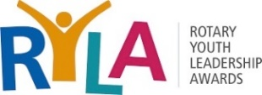
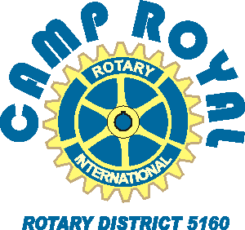
Rotary Club of __________________

Date: _______ 2023
Dear _________________Principal, __________(school)
The Rotary Club of ______ sponsors one or two students to Camp Royal, a youth leadership camp for high school juniors and we are asking for your assistance in identifying students that would benefit from such an experience. This is an awesome opportunity, totally funded by local Rotary clubs like ours. (And if you have more than two good candidates, we do keep a waiting list.)
The six-day camp is being held in June at BAR 717 ranch in the Trinity Alps Wilderness, just north of Hayfork, and promises to be an inspirational and engaging event. Here are some camper testimonials from last summer’s virtual camp:
Camp Royal made me learn about myself, how to practice wellness, and what it means to be a true leader; a great way to get to meet new people and learn/grow together and have fun; taught me much about community and the potential interaction that each of us can strive for; enjoyed the conversations, fun activities, and the mindful meditation; was able to meet a multitude of new friends, and talk about our future plans as students; most importantly, we were able to discuss our duties and skills as leaders, and plan for how we can positively impact our community; one of the most enlightening, exciting parts of the whole summer; w/o Camp Royal, I would not have gained the leadership skills needed to run my Interact club; the staff were so engaging even though they were online-I can’t imagine how amazing it would be to have the same experience in person!
Attached is a promotional poster, suitable for distribution to prospective attendees based on recommendations of counselors or teachers, or simply announcing/posting around campus. The QR codes on the poster include a short promotional video and a link to the www.CampRoyal.org website for more information. Also attached is an application form for camp. Completed applications should be returned to me by March 15th with your recommendations.
If you have any questions about the selection process, please contact me. Questions about the camp may be directed to the Registrar, Marc Monachello at 916 752 3707 monachello@hotmail.com
Sincerely,
_______________
President, Rotary Club of _________
(Email and/or phone) _____________

Application/Contact Form

To: Camp Royal Applicant
From: __________, President, Rotary Club of ____________
Thank you for showing an interest in participating in Rotary District 5160’s youth leadership camp, known as Camp Royal. Please complete this form to help in the selection process.
Camp dates: Monday, June 5 to Saturday, June 10, 2023 Attendees: Students from over 60 high schools in Northern California
Participants must be juniors, going into their senior year.
Name: |  | Gender: |  | Age: | Grade:
Home Address: | Cell phone: |  | Home Phone:
Your e-mail: Parent name and work phone:
High School:
List Current Activities at school (Sports, Clubs, Projects)
List Current Activities off campus (employment, clubs, volunteer work)
Have you selected a career goal? Explain...

Please attach a short essay on why you wish to attend Camp Royal.
If there any reason that you cannot participate for the entire time of the event (due to work, school, sports), please do not apply. Spotty participation adversely impacts your experience and those of your team members
Please initial you have read this. _____ Parent/guardian signature:_______________________ Date_____
Return the completed form by 15 Feb to: ________________________

