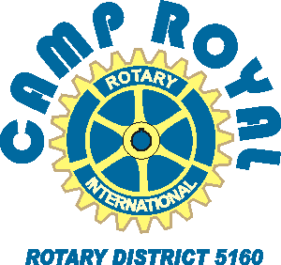
Sample communication to school contacts that may be assisting in identifying prospective ‘campers’.
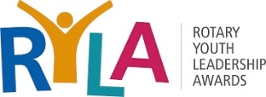

Dear (school contacts)
The Rotary Club of _____________ has supported Camp Royal, a youth leadership camp for high school juniors for decades and we are asking for your assistance in identifying one or two students (juniors or seniors) that would benefit from such an experience.
This year’s event (June 14-17) is virtual, due to covid related safety concerns, but our internationally renowned program director is experienced in virtual programs and promises an inspirational and engaging event.
Here is a link to a promotional poster (click on pdf and/or jpg), suitable for distribution to prospective attendees. If desired, email our Registrar (gwegener4098@gmail.com) with the school contact info to put in the box (under ‘Apply By’) and he will add it and resend you the poster. This facilitates distribution by email if desired. The QR codes on the poster include a short promotional video and a link to the www.CampRoyal.org website for more information. You may wish to use this application form to facilitate
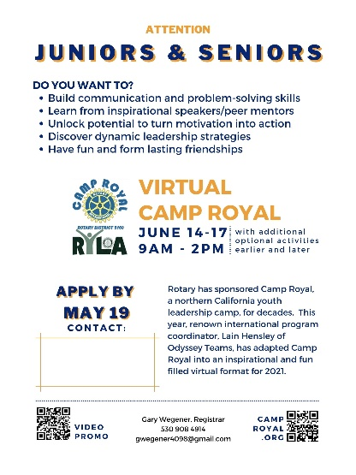
Regrettably, the deadline to get student name(s) and contact info is May 19th. Please contact me if you have any questions.

Sincerely,
Name
Camp Royal Chair for the Rotary Club of ______________
Phone/email.

Attachments: (please add…)
Application form to help you in selecting student

