ATTENTION
High School JUNIORS
DO YOU WANT TO:
- Build communication and problem-solving skills
- Learn from inspirational speakers/peer mentors
- Unlock potential to turn motivation into action
- Discover dynamic leadership strategies
No cost to student/100% Rotary funded

- Have fun and form lasting friendships

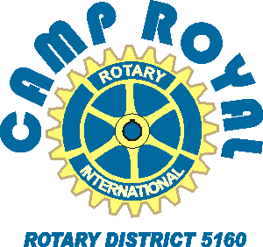
CAMP ROYAL 2022
July 24-29

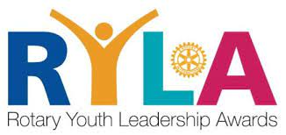
Rotary has sponsored Camp Royal, a northern California youth leadership camp, for decades. Learn new life skills in a beautiful setting.

Apply by March 1st
Submit completed application to:
(POC name, email, phone)
(enter camper contact info by Mar 15)

Camp Application
CampRoyal.org
Camp Royal video
For more information, contact: Gary Wegener, Registrar 30 908 4914 Gwegener4098@gmail.com

