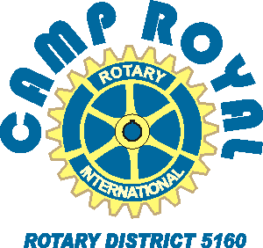
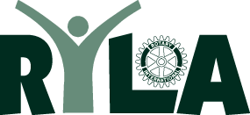
d

Application/Contact Form

To: Camp Royal Applicant
From: (name, Rotary Club)________________________________________

Thank you for showing an interest in participating in Rotary District 5160’s youth leadership camp, known as
Camp Royal. Please complete this application form and return to (name, email, phone) _________________
____________________________________________________________________________________________.

Camp Dates: Sunday, July 24 to Friday, July 29, 2022
Attendees: students from over 60 high schools in Northern California
Participants must be juniors, going into their senior year.

Name: |  | Gender: |  | Age: | Grade:
Home Address: | Cell phone: |  | Home Phone:
Your e-mail:

Parent name and work phone:

High School:
List Current Activities at school (Sports, Clubs, Projects)
List Current Activities off campus (employment, clubs, volunteer work)
Have you selected a career goal? Explain...

Please attach a maximum one page essay as to why you wish to attend Camp Royal.

If there any reason that you cannot participate for the entire time of the event

(due to work, school, sports), please do not apply. Spotty participation adversely impacts your experience and those of your team members

Please initial you have read this. _______ Parent/guardian signature:_______________________

For Rotary Club Camp Royal Chair: please enter the contact information for your sponsored ‘campers’ in the DacDB slot reservation webpage by 15 March. Contact Gary Wegener, Registrar at 530 908 4914 (gwegener4098@gmail.com) if you have any questions.

