Gearing Up for Student Summer Camps by Kaitlyn Yergenson
“Life changing.” The most common two-word phrase used to describe Camp Royal.
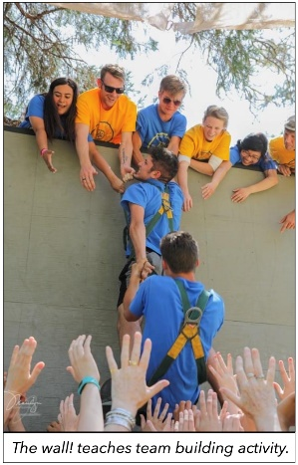
Camp Royal is a District 5160 decades-long tradition, nurturing high school students to become tomor-row’s leaders. It’s a week-long off-the-grid summer camp experience, jam-packed with internationally recognized speakers, team building activities, and personal skill-sharpening.
Former Camp Royal campers have a tough time choosing their favorite part of the week. Was it the practice of mindful meditation, the team dynamics at the ropes course, the discovery of their own intrinsic leadership skills, or simply learning the power of building a supportive community? For me it was all of the above, and I’m writing this letter 15 years after attending camp as a high school senior. It is, in fact, a life changing experience that Rotary makes possible for 130+ teens a year.
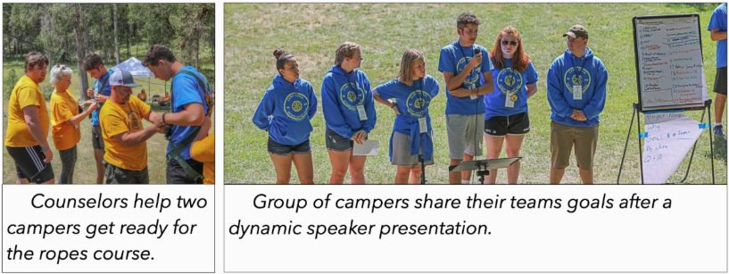

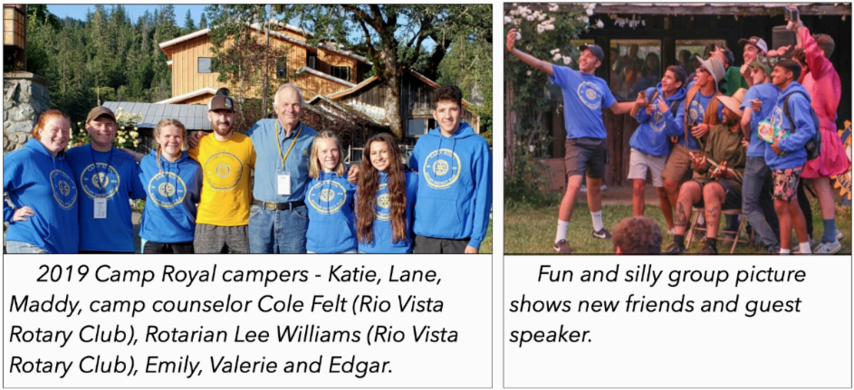

Don’t just take our word for it. Last year’s Virtual Camp Royal 2021 was “one of the most enlightening and exciting parts of the whole summer” claims Tia C., a student from Liberty High School (Brentwood Rotary). And that was on Zoom!
Camp Royal is back IN PERSON, this year! We cannot wait to continue the 5160 tradition of leadership. Is your club sponsoring a Student? See camproyal.org

