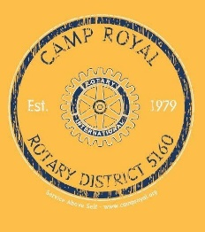

CAMP ROYAL 2022 PACKING LIST

Congratulations, you are in for the adventure of your life! Pack well and be prepared for anything. You will have your Camp Royal T-shirt and Hoodie on 99% of the time at camp.

- 3 Long-sleeved shirts for under your camp t-shirt if you get cold
- 3 Shorts (6-inch inseam or mid-thigh please)
- Long pants (2)
- Conservative Swim-suit(s)
- Undergarments (enough for one week)
- Socks (enough for one week)
- Rain jacket (You will get a CAMP Royal Hoodie as a gift)
- Tennis shoes or boots
- Sandals/flip flops
- Flash Light or headlamp
- Batteries
- Warm Sleeping Bag
- Pillow
- Swim towel
- Bath towel
- Wash clothe
- Soap
- Hair Brush/Comb
- Shampoo & Conditioner
- Toothbrush & Toothpaste
- Chap-stick
- Sunscreen
- Insect repellent
- Medications*
- WATER BOTTLE

Add whatever other items to make your stay comfortable. Note: Hair dryers and other electric items cannot be used - no power outlets are available.

*Any prescription medication you bring must be in prescription containers. Over the counter medications must be easily identifiable. The medical staff at camp will inventory and will need to store your medication for you. Please bring all medicine in a zip-lock bag.

