Attention
High School Juniors
Do you want to:
- Build leadership skills
- Enhance communication and problem solving skills
- Learn from inspirational speakers/ peer mentors
- Unlock potential to turn motivation into action
- Have fun and form lasting friendships

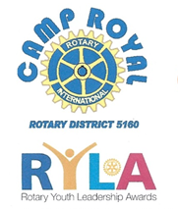
Camp Royal 2023
June 5-10

Rotary has sponsored Camp
Royal, a northern California
youth leadership camp, for
decades. Learn new life
skills in a beautiful setting.

All camp fees covered by Rotary, no cost to students!

Apply by February 15, 2023

For more information contact Marc Monachello @monachello@hotmail.com or 916 752 3707
