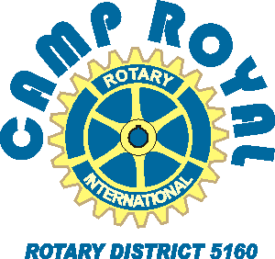

2021 Application Form

Thank you for showing an interest in attending Rotary District 5160’s “Virtual” Camp Royal. We invite you to complete this form to help our committee select this year's “campers”.

Camp Royal Dates: 9am-2pm (w/ earlier/later optional activities) M-Th June 14 thru June 17, 2021
Location: Virtual for 2021, due to covid concerns. Totally Rotary funded.
Attendees: typically ~138 Juniors/Seniors from over 60 high schools in Northern California
Due date: NLT May 19, 2021
Selection process: Final selection subject to approval by the Camp Royal Committee
Cost: No cost to participating students; funded by local Rotary Clubs in the district.

Promo Video WWW.CampRoyal.org

Name: |  | Age: | Grade:
Home Mailing Address: | Home Phone:
Your e-mail and cell phone number:

Parent name and work phone:

High School:
List Current Activities at school (Sports, Clubs, Projects)
List Current Activities off campus (employment, clubs, volunteer work)
Have you selected a career goal? Explain...
Please do not apply if you cannot be available during the 9 to 2 timeframe each day.

Please initial you have read this. ____________ Parent/guardian initials:___________________

Return to (address/email): CampRoyal@Rotary5160.org
or mail to Gary Wegener, Camp Royal Registrar, 30 Roman Court, Woodland, CA 95776.

