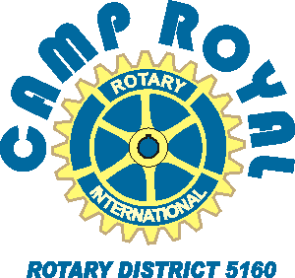

Application/Contact Form

To: Camp Royal Applicant
From: Place Your Rotary Club Here

Thank you for showing an interest in participating in Rotary District 5160’s youth leadership camp, known as
Camp Royal. Please complete this form to help in the selection process.

Dates: Monday, June 5 to Saturday, June 10, 2023
Attendees: students from over 60 high schools in Northern California
Participants must be juniors, going into their senior year.

Name: |  | Gender: |  | Age: | Grade:
Home Address: | Cell phone: |  | Home Phone:
Your e-mail:

Parent name and work phone:

High School:
List Current Activities at school (Sports, Clubs, Projects)
List Current Activities off campus (employment, clubs, volunteer work)
Have you selected a career goal? Explain...

Please attach a one page essay as to why you wish to attend Camp Royal. Required Not Required

If there any reason that you cannot participate for the entire time of the event

(due to work, school, sports), please do not apply. Spotty participation adversely impacts your experience and those of your team members

Please initial you have read this. ___________ Parent/guardian signature:___________________

Please return the completed application(s) and recommendations by March 31
Please place your club contact information in here.

